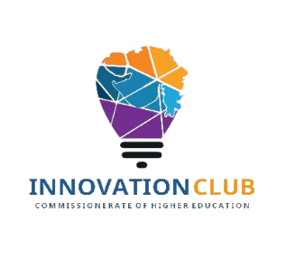
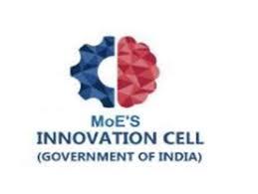
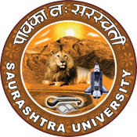
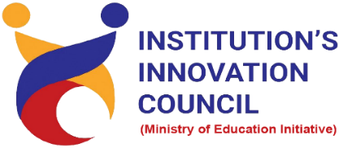

Entrepreneurship for Sustainable Development

21th January2023
At
NFDD Building
Saurashtra University, Rajkot

Contents
Saurashtra University-IIC 3
About G20 3
Event Schedule 3
Brief about Event 4
Key Points 5
Outcome 5
Registration Link 5
About the speaker/ Chief Guest 6
Connect Us 9

Saurashtra University-IIC

The university is dedicated to instruction, research, and extending knowledge to the public (public service). Ministry of Education (MoE), Govt. of India has established ‘MoE’s Innovation Cell (MIC)’ to systematically foster the culture of Innovation among all Higher Education Institutions (HEIs). The primary mandate of MIC is to encourage, inspire and nurture young students by supporting them to work with new ideas and transform them into prototypes while they are informative years. Saurashtra University is one the Organization that have constituted the IIC to foster the vision of MoE and be a part for the promotion and development of innovation ecosystem.

About G20

India holds the Presidency of the G20 from December 1, 2022. The theme of India’s G20 Presidency - “Vasudhaiva Kutumbakam” or “One Earth · One Family · One Future”. It works to address major issues related to the global economy, such as international financial stability, climate change mitigation, and sustainable development.

Event Schedule

Time | Program
12:00 pm | Registration
12:00pm – 12:15 pm Inauguration & Welcome
12:15 to 12:30 | Orientation Session and Brief about G20 by Dr. Harikrishna Parikh
12:30 to 2:00 | 1st Session by Mr. Mitesh Vadher on Topic of Startup Ecosystem  Support Framework for Innovators & Startups
2:00 to 2:30 | Lunch Break
2:30 to 3:30 | 2nd Session by Mr. Parth Sejpal on Topic of Entrepreneurial Eco  system for Start-up
3:30 to 4:15 | 3rd Session by Dr. Ranjan Khunt on Topic of How Start-up
4:15 to 4:30 | High Tea
4:30 to 5.15 | 4th Session by Dr. Harikrishna Parikh on Topic of Sustainable Development
5:15 to 5:45 | 5th Session by Dr. Hitesh Shukla Entrepreneurship for Sustainable Development
5:45 to 6:00 | Concluding and Thanks - Mr. Parth Sejpal, CEO, SU Startup And Entrepreneurship Council
6:00 | Networking tea and Snacks

Brief about Event

SU Start-up and Entrepreneurship Council (SUSEC) organized one day seminar of Entrepreneurship for Sustainable Development on 21th January 2023. Function started with lighting of lamp. We welcomed our guest with memento gift. Afterword, session started with inauguration and welcoming. Dr. Harikrishna Parikh had shared brief about G20. All the speakers shared their knowledge related to how to SSIP useful to students.
Session delivered by Mr. Mitesh Vadher on Startup Ecosystem Support Framework for Innovators & Startups. Students had learned about Opportunity, Innovation, Funding Sources, Scheme for Startups. The process of recognition as a ‘Startup’ shall be through an online application set up by the Department for Promotion of Industry and Internal trade. Personal Savings, Family & Friends, Government Grants, Crowdfunding, Venture Capital, Angel Investors are the sources of funding. Up to Rs. 20 Lakhs as grant for validation of Proof of Concept, or prototype development, or product trials. Also, queries of students were solved by speaker.
Session delivered by Mr. Parth Sejpal on Entrepreneurial Eco system for Start-up Learning & Implementation. Students had learn about Entrepreneur in different point of view. Traits of Entrepreneurs got knowledge for that we need to require micro analysis for starting up business. Risk tolerance, mental ability and creativity, leadership skill, clear objective are the affected factors for entrepreneurs. Got knowledge how forming the Enterprise and for that which process we need to follow also required documents. Sir discussed that entrepreneurship is a creative destruction force that sees the destruction of usual ways of doing things by the introduction of new improved ways.
Session delivered by Dr. Ranjan Khunt on student startup and innovation policy. Madam shared knowledge about SSIP 2.0. vision of SSIP is that empowering the young population of the state to unlock their creative potential through Start-up and Innovation so, as to enable them to contribute for sustainable development and inclusive growth towards the realization of Aatmanirbhar Gujarat. Also discussed about SSIP 1.0 & 2.0 comparison, what is salient features of SSIP 2.0, what is eligibility to receive SSIP 2.0 grant at university level and school level, role of individual beneficiary etc.
Session delivered by Dr. Harikrishna Parikh on topic sustainable development. Sir has discussed about what is development, types of development, sustainability, pillars of sustainability etc. sustainable development is an organizing principle that aims to meet human development goals while also enabling natural systems to provide necessary natural resources and ecosystem services to humans. Sustainability required for us and for future generation. Many hurdles were discussed Poverty and Inequality, economic reforms and governance.
Session delivered by Dr. Hitesh Shukla on topic of innovation management and innovation dimensions. For building sustainable business models need to analyse purpose, people, strategy assets, value proposition. Sir has discussed about how to test business idea. Industry competitors, potential entrants, buyers, substitutes, suppliers all are the affected factors for business development. Sir had described about how to forming the enterprise. Financial management is important part for business development.
After completion of each speaker session students asked questions to speaker. The speakers addressed the queries of all the students. Mr. Parth Sejpal had given concluding speech.

Key Points

During the visit, below mentioned points were consider:
- Human Resource Management
- Operations Strategy
- Pillars of Sustainability
- Business Opportunity
- Inspiration
- Human Resource Management
- Protecting Ideas

Outcome

As per the event, got knowledge that sustainable entrepreneurship is one of the instruments to achieve sustainable development Goals that "define global priorities for development up to the year 2030 and are pivotal for addressing the global economic, social and environmental challenges faced by the communities. Sustainable entrepreneurship refers to the discovery, creation, and exploitation of entrepreneurial opportunities that contribute to sustainability by generating social and environmental gains for others in society. Main benefit, you can earn more money and boost your bottom line by making your business more sustainable.

Registration Link

bit.ly/SUSEC-EFSD

About the speaker/ Chief Guest
- Mr. Parth Sejpal
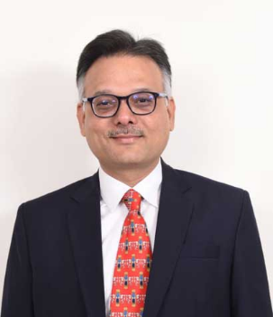
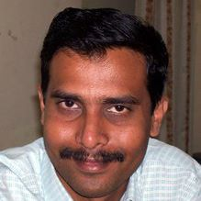
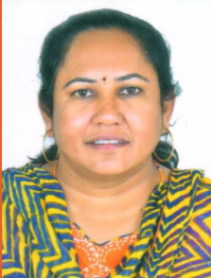
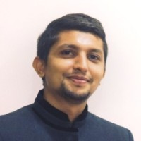
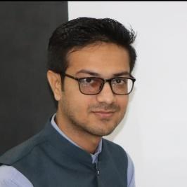

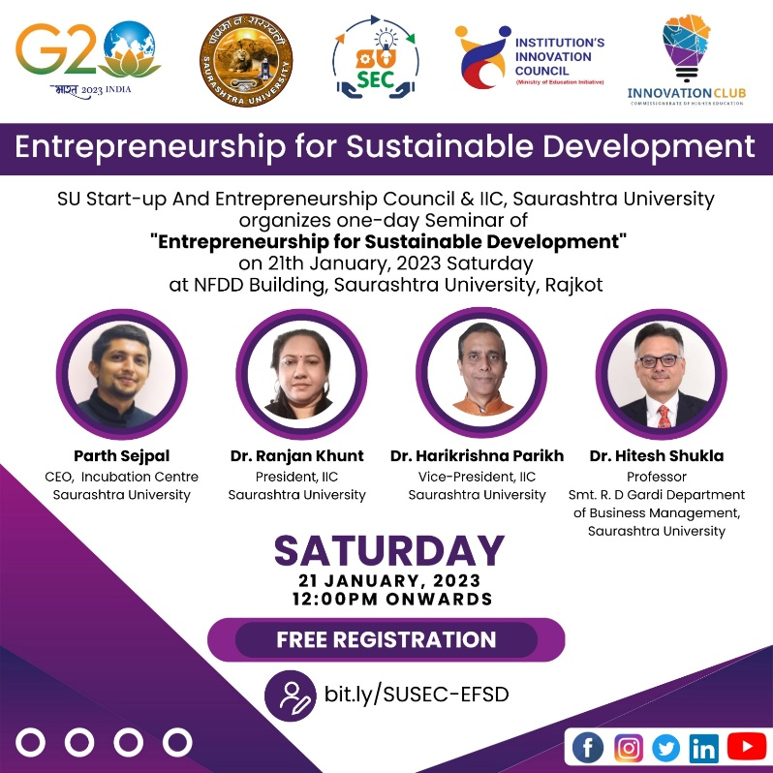
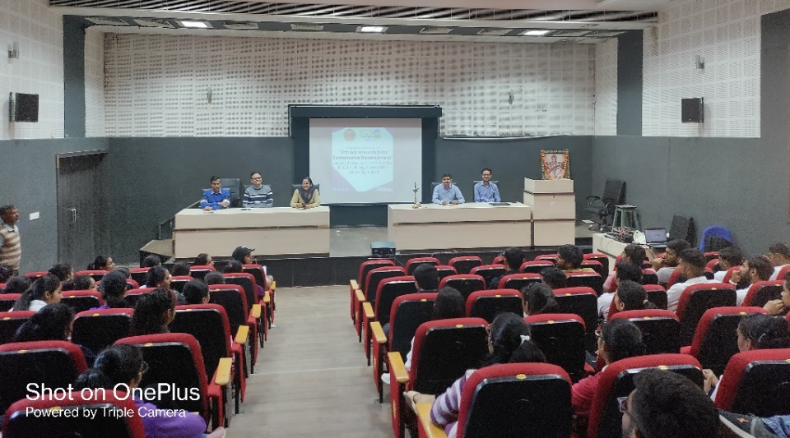

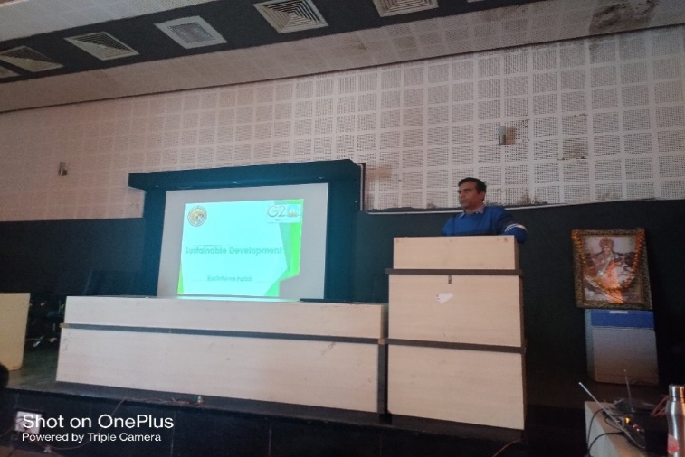
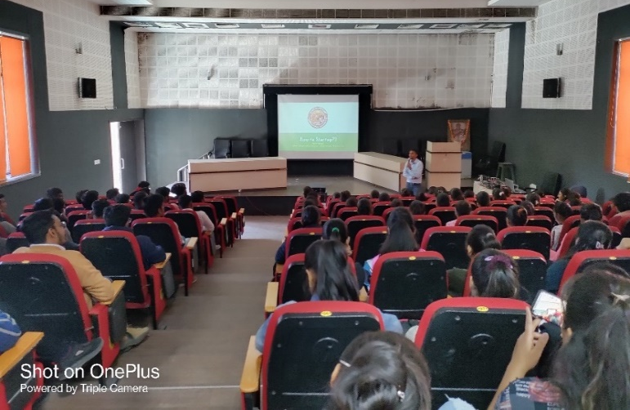
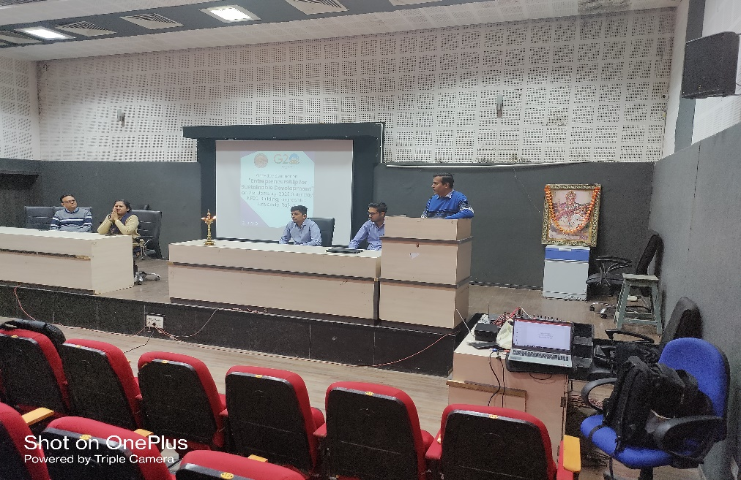
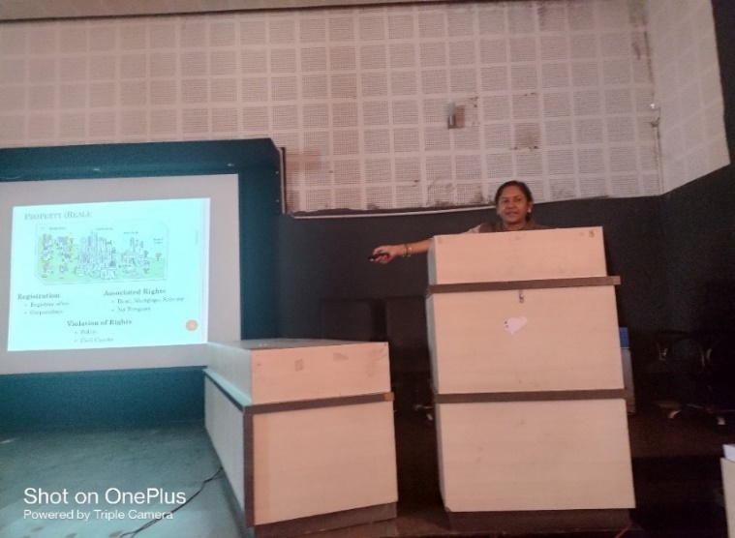
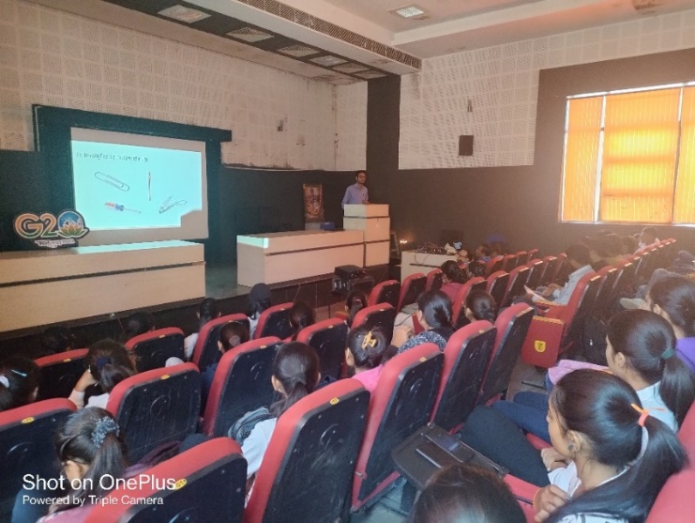

Connect Us

https://www.linkedin.com/company/susec iic@sauuni.ac.in
https://www.facebook.com/iicsauuni https://bit.ly/SUSEC-Location
https://www.instagram.com/susecrajkot https://bit.ly/SUSEC-youtube

